**Visualizing Housing Prices Data in Metropolitan Areas of India**

**Data Source-** <https://www.kaggle.com/datasets/ruchi798/housing-prices-in-metropolitan-areas-of-india>

✅ **TASK 3: Data Visualization**

**Project Introduction: Bangalore Housing Market Visualization**

This project analyzes Bangalore housing prices using data visualization. We explore price distribution, the impact of area and bedrooms, and location-based value. The goal is to provide clear, data-driven insights for informed real estate decisions, transforming complex data into a compelling visual story.

**Step 1:** **Transform raw data into visual formats like charts, graphs, and dashboard using python packages. Craft compelling data stories that support decision-making: Interpreting the visuals and revealing the insights.**

* **Distribution of Housing Prices (Histogram):** This helps to understand the frequency of different price ranges in the dataset.

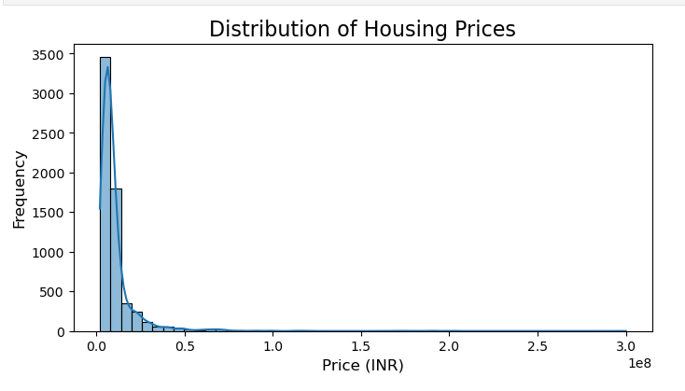

* The histogram is heavily right-skewed, indicating a very large number of properties are concentrated at the lower end of the price spectrum.
* There's a very tall, narrow peak on the far left, indicating that the most frequent prices are relatively low.
* The curve (KDE - Kernel Density Estimate) and the bars gradually decrease in height as one moves to the right, forming a long "tail."
* The market has a strong base of more affordable properties. Most transactions or listings fall within a lower price range. Luxury segment represents a much smaller portion of the overall market in terms of volume. Thus, we can conclude that the typical buyer of property in this dataset is not in the ultra-luxury segment.
* **Housing Price vs. Area (Scatter Plot):** This gives the relationship between the size of a property and its price.

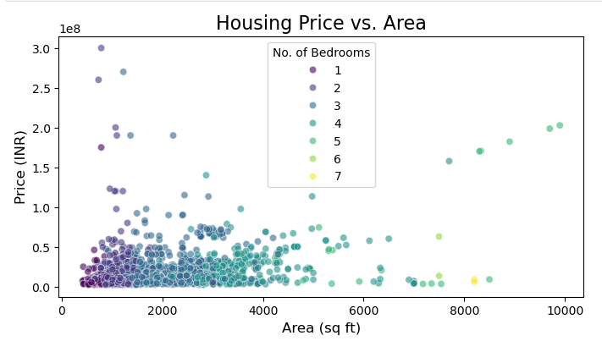

* There's a clear **positive correlation** between Area and Price. This is expected: larger homes generally cost more.
* Most of the data points are clustered in the lower-left portion of the graph, indicating that a majority of properties are smaller in area and lower in price. This aligns with the histogram's observation of many properties in lower price ranges.
* **Influence of Bedrooms (Color Insight)-** Fewer bedrooms (purple/blue dots) are predominantly found in the lower-left, indicating smaller areas and lower prices. (Green/yellow dots) are higher in concentration towards larger areas and higher prices. Though rare, houses with fewer bedrooms are found at higher areas.
* **Outliers:**
* **High Price for Low Area:** These could be luxury apartments in prime locations.
* **Low Price for High Area:** These might represent properties in less developed areas, properties needing significant renovation, or potential distressed sales.
* **Housing Price by Number of Bedrooms (Box Plot):** This shows how housing prices vary based on the number of bedrooms, highlighting median prices and price distributions for each category.

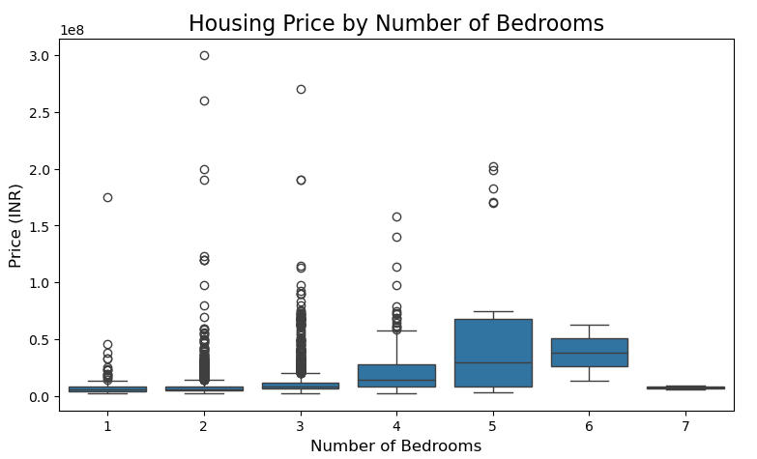

* Generally, the median housing price (middle line of each box) increases as the number of bedrooms rises from 1 to 5.
* Lower bedroom counts (1-3) show numerous high-priced outliers, indicating a segment of premium or luxury smaller properties.
* Properties with 4 or 5 bedrooms exhibit a wider range of prices (taller boxes), suggesting more variability in this segment.
* There are very few properties with 6 or 7 bedrooms, making their price distributions less statistically robust.
* **Top 10 Locations by Average Housing Price (Bar Chart):** This identifies the most expensive areas based on average property prices.

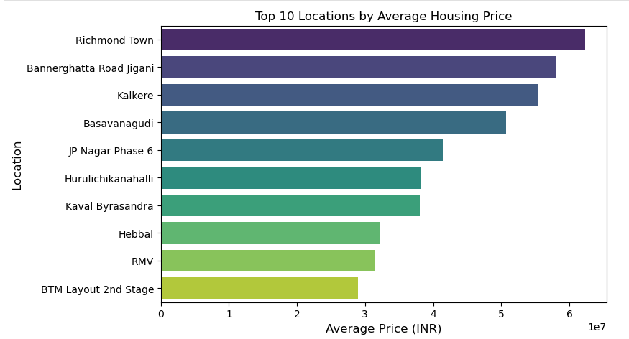

* Richmond Town consistently holds the highest average housing price, followed closely by Bannerghatta Road Jigani.
* There's a clear gradient in average prices among the top 10, with a noticeable drop as one moves down the list from Richmond Town to BTM Layout 2nd Stage.
* This plot effectively highlights the most premium and high-value residential areas within the Bangalore housing market, based on the average cost of properties.
* Where a property is located within Bangalore is a primary determinant of its average price, often outweighing other factors
* **Correlation Heatmap:** This shows the correlation between numerical features.

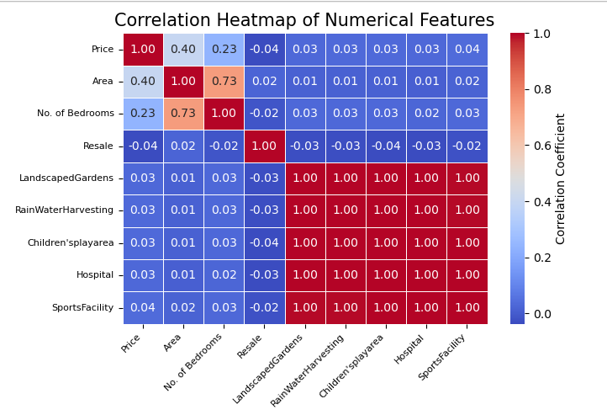

* There is a **moderate positive correlation** between Price and Area, suggesting that price rises with increase in area, but other factors also influence.
* There is a **weak positive correlation** between Price and No. of Bedrooms, this might be because 'No. of Bedrooms' often correlates strongly with 'Area' itself.
* There is a **strong positive correlation** between Area and No. of Bedrooms, and this is expected.
* There is a **very weak negative correlation** between Price and Resale, suggesting no linear impact of the Resale status on price.
* All these amenities show very low correlations with Price. Amenities chosen here belong to environment friendliness (Landscaped Gardens, Rain Water Harvesting), necessities (like hospital), and activities promoting health and recreation (Children’s play area, Sports Facility). None of these being substantially correlated may imply either lack of awareness regarding the requirements of these or they are standard features in most properties, so they don't differentiate price much.

Also, their impact on price may be non-linear and hence remained uncaptured.

* **Average Price per Square Foot by Location**: This plot helps normalize prices by the size of the property, giving a better understanding of the value obtained for money in different areas, rather than just the absolute price which can be heavily influenced by property size.

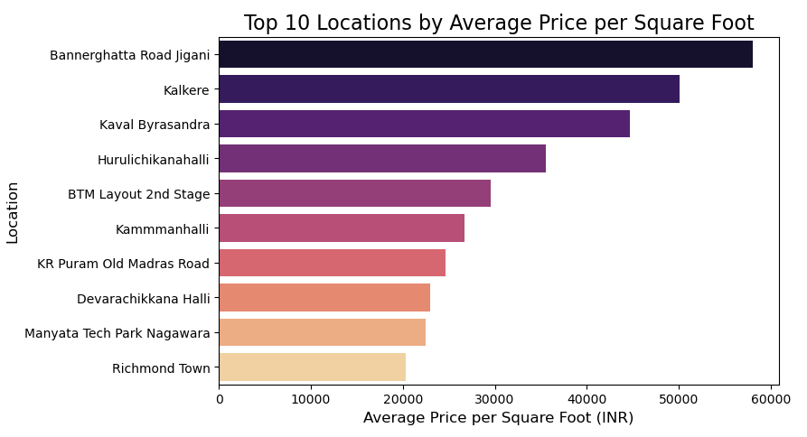

* Bannerghatta Road Jigani and Kalkere have the highest average price per square foot, making land and property in these areas most expensive per unit.
* Richmond Town, which was the most expensive location by *average total price*, appears at the *bottom* of this list for average price per square foot. This suggests that while properties in Richmond Town are expensive, they might also be significantly larger on average, thus bringing down their per-square-foot cost relative to other areas.

**💡 Actionable Insights for Decision-Making:**

* Buyers should focus on properties where the "Price per Sq Ft" is lower for the desired area, especially in emerging or slightly less central locations.
* More emphasis should be given to the total area of your property, as it's a primary price driver. Amenities are good to attract buyers, but their direct impact on the sale price might be limited.
* Well-designed, mid-sized affordable properties have high demand probably due to many jobseekers migrating there. This market could be targeted.
* Land in locations with high "Average Price per Sq Ft" should be prioritized for maximum return on investment, even for smaller units.

**Step 3: Build a strong portfolio with impactful and well-designed visualizations.**

<http://localhost:8888/lab/tree/compiled_housing_dashboard.png>

